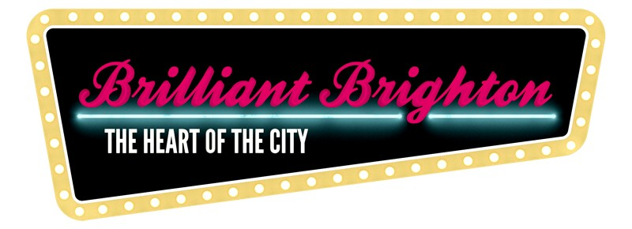Brighton BID Ltd

Administration & Events Assistant

BACKGROUND

(additional information and news stories can be found on our website www.brilliantbrighton.com)

1) The Brighton Business Improvement District (BID) encompasses 517 businesses in Brighton City centre.

2) In 2021 businesses voted to pay an additional levy on top of their Business Rates to pay for Christmas Lights, Security and a project to dress the city in the summer months. The Brilliant Brighton BID has now being running for over 15 years.

3) The BID provides the Brilliant Brighton webpage, Twitter, Facebook and Instagram pages

4) The BID also supplies deals and offers to support local businesses and help Brighton city centre to remain sustainable and competitive

5) The aim of the BID is to improve Brighton city centre for everyone that visits, lives or works here.

6) CORE ACTIVITY
Core activities of the initiative include: -

a) City Centre Christmas Lights
Costing over £100,000 per annum, Brighton’s Christmas Lights are the largest displays on the South Coast. Our displays cover Western Road, North Street, East Street, Market Place, Brighton Place, Meeting House Lane, Bond Street, Gardner Street and Kensington Gardens.

b) On Street Security
The BID pays for Brighton’s City Centre Ambassadors. Their role is dual fold; first they are there to provide an older sibling presence on the high street, directing individuals to their destinations, and generally acting as a welcoming presence to the city. Secondly, they deter crime and anti-social behaviour, working closely with the city’s award winning Business Crime Reduction partnership and Sussex Police. To date, in the last financial year, they have returned over £50,000 worth of stolen goods to BID shops and support the arrest of over 200 criminals.

c) Dressing the City
The annual display of bunting, banners and hanging baskets give the BID area a festival feel throughout the summer months. More than 1800m of bunting is put in place and hundreds of hanging baskets and banners are installed on BID streets to lift the city centre from May through to September.

d) Website and PR
The BID’s trading name is Brilliant Brighton and in 2011 we launched www.brilliantbrighton.com. With over 14,000 social media followers, we aim to be go-to resource for offers and news from Brighton’s city centre shops, bars and restaurants. We also provide a free online business listing for every BID member.

e) Offers/discounts and deals
The BID regularly negotiates deals with providers to reduce business costs. We currently promote a range of offers to our 517 members saving. BID business can save in the region of £1000 per month by signing up to a handful of our most popular deals.

f) Communications
The BID manages quarterly newsletter and weekly e-updates to keep our members abreast of events and activity from the BID management team.
g) Cleansing
The BID manages regular street cleansing and graffiti removal in the city centre.
h) Events
The BID works with partners to deliver a calendar of events in Brighton City Centre. This has included shopping trails, Third Thursday Events, Arts Trails and more.

7) JOB TITLE Administrative Assistant

LOCATION Brighton Town Hall/ remote

RESPONSIBLE TO Marketing and Events Manager / BID CEO

HOURS OF WORK 25 hours per week (some evening working will be required)

EMPLOYER Brighton BID Ltd

Main Purpose of Role:

- To support the general office administration of the BID

Main Responsibilities

- To develop and maintain the BID database
- To develop and maintain the BID online listings
- To support the Marketing Manager to maintain and grow the Brilliant Brighton website and social media platforms
- With the Marketing Manager, to liaise with arts organisations and partner organisations to deliver a calendar of on-street activity
- With the BID Marketing Manager, to undertake quarterly vacancy rate analysis
- To provide all necessary administrative assistance when required i.e. mailouts, meetings, disseminating papers, minute taking etc
- To keep members updated with regular email communications
- To keep members updated with a quarterly paper newsletter
- To keep the BID database up to date with all the relevant contact details
- To keep the BID web-based membership listings up to date
- To update photographs to listings when necessary
- To upload offers/new items to the Brilliant Brighton website
- To use social media to promote Brilliant Brighton Businesses
- To support all BID meetings, including Board Meetings & AGM

Person Specification

Administrative + Events Assistant |  | Shortlisting Criteria  Essential/  Desirable
Key Knowledge | Knowledge of, or a willingness to learn about, Business Improvement Districts | E
Qualifications and Relevant Experience | A Levels  Experience of working with retailers / leisure industry  Experience of small-scale event coordination | E  D  D
Key Competencies | I.T Skills  Fluent in Microsoft Office applications  Ability to use DTP software. E.g Canva  Ability to manipulate data online using Wordpress  Building Effective Partnerships  Ability to develop productive working relationships with a diversity of individuals, stakeholders and all potential partners in service delivery.  Communicating in writing/orally  Able to produce clear, succinct and well structured written work  Confident in speaking with businesses in person and on the telephone  Co-ordinating Projects  Ability to apply available resources in an organised manner, translating plans into action and objectives into realities.  Delivery Results  Able to meet deadlines and targets, demonstrating an ability to achieve despite challenges or obstacles.  Celebrating Diversity  Promote positive recognition of differences, mutual respect and merit-based opportunity. | E  E  E  D  E  E  D  E  E

12) JOB DETAILS
This is a part time position.

The post may require some evening working

Pay £25,000 f/t pro rata (Based on 40 Hours p/w)
Hours 25 hours/week
Holiday pro rata days/annum + all public holidays
Employer Brighton BID Ltd
Pension Stakeholder pension (Non-contributory from employer)

