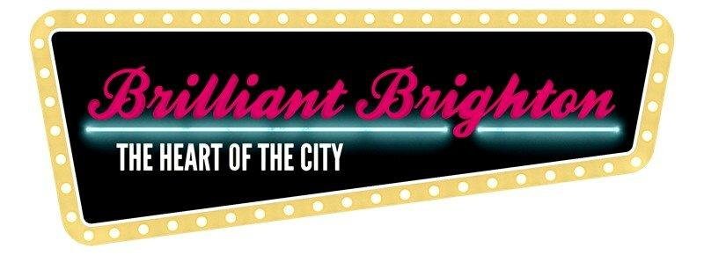
Brilliant Brighton
Brighton City Centre Dressing Campaign Design Brief 2024
Total commission: £1,000
Who are we:
Brilliant Brighton is the name given to the Brighton City Centre Business Improvement District (BID).
A BID is a group of businesses that come together to fund a range of improvements to a town or city centre for the benefit of all. In Brighton’s case the businesses fund the annual Christmas Lights, the city centre Ambassadors, the Brilliant Brighton website and social media as well as a project to ‘Dress the City’ in the summer months from May through to September. To find out more, visit us online at www.brilliantbrighton.com/about.
Next summer, we want to adorn the city centre with bright, colourful designs which will be seen by millions of city centre visitors to Brighton. There will also be a significant online PR exercise to promote the summer dressing campaign as well as radio and press coverage, helping to raise the profile of the winning artist within the city and beyond.
Concept:
The project will go live in time for the beginning of the Brighton Arts Festival in May. Your designs will be in place above Western Road and North Street in time for the annual Children’s’ Parade and will stay in situ until the end of September 2024. Your artwork will become the city’s summer ‘brand’ and give you unparalleled exposure to a local, national and international audience.

- To design a banner scheme for Brighton City Centre which will be on display from May through to September
- You will need to design 8 – 10 individual images that can then be repeated across the scheme
- There are 13 Street Crossings in total along Western Road and North Street. Previously, each crossing has held 5 banners (2m deep by 1m wide) or 3 banners (2x 2m deep and 1m wide and 1 x 5m wide and 2m deep) see previous examples below
- 10 lamp column banners on Preston Street (0.5m x 1.5m)
- Crossings can be designed as separate banners, single banners, pennants, or something unique
- Each crossing will need to include one banner for partner logos (including details of the winning artist)
- Scheme will be seen by over 11m annual visitors to the city. Online PR campaign via social media will also widen this
- The Board of Brilliant Brighton will need to see three design concepts initially, before deciding on the winning entry. Designs can either be per crossing or city centre wide scheme. However, only one artist will receive the commission for the work

Theme:
The 2024 theme is All the colours of Brighton and can be interpreted as you see fit. The city centre has 15 cross street banner points (see below) which cross Western Road, North Street and Market St. We would like to see as much colour and flare as possible to give Brighton’s 11m visitors a real welcome to our vibrant, colourful city. The design brief is purposefully loose to allow as much freedom as possible – however, we would expect the concepts to be Brighton & Hove focussed, with graphics showcasing everything that is great about Brighton & Hove, from its diverse, alternative nature to its family friendly activities, attractions and… buzz.
Deadlines:
Deadline for submissions: 29th February 2024
Shortlisting: Fri 1st March 2024
Board Decision: w/c 3rd March 2024
Final Deadline for Design Delivery: w/c 1st April 2024
Submission Details:
Please submit your website link along with a brief art CV, covering letter along with brief concept ideas to:
Gavin Stewart
Brilliant Brighton
07772 488351 / gavin.stewart@brightonbid.com
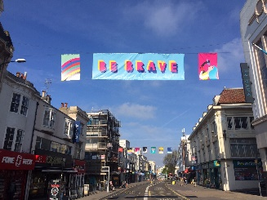 | 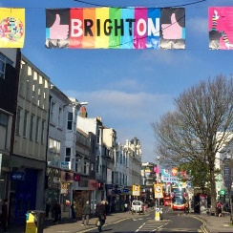 | 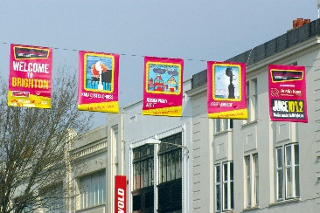

Locations:
Western Road
North Street
Preston Street (Lamp Columns)

