**Brilliant Brighton  
Brighton City Centre Dressing Campaign Design Brief 2025**

**Total commission: £1,000**

**Concept Theme – The Energy Never Stops**

**Who are we:**

Brilliant Brighton is the name given to the Brighton City Centre Business Improvement District (BID).

A BID is a group of businesses that come together to fund a range of improvements to a town or city centre for the benefit of all. In Brighton’s case the businesses fund the annual Christmas lights, the city centre Ambassadors, the Brilliant Brighton website and social media as well as a project to ‘**Dress the City**’ in the summer months from May through to September. To find out more, visit us online at [www.brilliantbrighton.com/about](http://www.brilliantbrighton.com/about).

This summer, we want to adorn the city centre with bright, colourful designs which will be seen by millions of city centre visitors to Brighton. There will also be a significant online PR exercise to promote the summer dressing campaign as well as radio and press campaigns , helping to raise the profile of the winning artist within the city and beyond.   
 **Concept:**

* **To design a banner scheme for Brighton City Centre which will be on display from May through to the end of August.**
* **You will need to design 8 – 10 individual images that can then be repeated across the scheme.**
* **There are 13 street crossings in total along Western Road and North Street. Previously, each crossing has held 5 banners (2m deep by 1m wide) see previous examples below.**
* **10 lamp column banners on Preston Street (0.5m x 1.5m).**
* **Crossings must be designed as 5 separate, single banners or pennants.**
* **Each crossing will need to include one banner for partner logos (including details of the winning artist).**
* **Scheme will be seen by over 11m annual visitors to the city. The scheme will also be promoted on Brilliant Brighton’s social media accounts in a campaign running from May - August.**
* **The Board of Brilliant Brighton will need to see three design concepts initially, before deciding on the winning entry. Designs can either be per crossing or city centre wide scheme.**
* **Only one artist will receive the commission for the work.**

**The project will go live in time for the beginning of the Brighton Festival in May. Your designs will be in place above Western Road and North Street in time for the annual Children’s’ Parade and will stay in situ until the end of August 2025. Your artwork will become the city’s summer ‘brand’ and give you unparalleled exposure to a local, national and international audience.**

**Theme:**

2025 sees the Women’s Rugby World Cup come to the city. We are excited to celebrate this, and have chosen their competition slogan, **“The Energy Never Stops”** as the prompt for this year’s artwork.

However, we don’t expect the banner designs to be rugby focused (although a nod to this would be fine). The idea of the energy never stopping fits beautifully with our wonderful city and you are at liberty to interpret it in any way that you see fit.

The city centre has 15 cross street banner points which cross Western Road, North Street and Market Street. We would like to see as much colour and flare as possible to give Brighton’s 11m visitors a real welcome to our vibrant, colourful city. The design brief is purposefully loose to allow as much freedom as possible – however, we would expect the concepts to be Brighton & Hove focussed, with graphics showcasing everything that is great about Brighton & Hove, from its diverse, alternative nature to its family friendly activities, attractions, businesses and above all, energy!

**Deadlines:**

**Deadline for submissions: Sunday 2nd March (Midnight)**

**Shortlisting: Monday 3rd March 2025  
  
Board Decision/commission award: w/c 3rd March 2025**

**Final Deadline for Design Delivery: Tuesday 1st April 2025**

**Submission Details:**

Please submityour website link along with a brief art CV, covering letter along with brief concept ideas to:

**Gavin Stewart  
Brilliant Brighton  
07772 488351 /** [**gavin.stewart@brightonbid.com**](mailto:gavin.stewart@brightonbid.com)

|  |  |  |
| --- | --- | --- |
|  |  |  |

|  |  |  |
| --- | --- | --- |
|  |  |  |

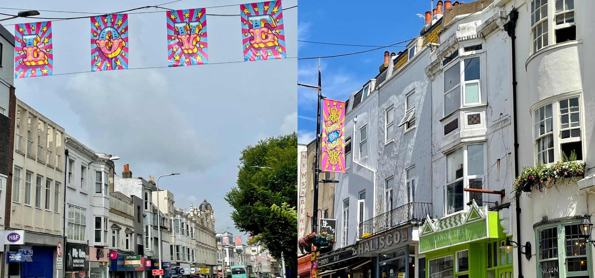

**Locations:**

**Western Road**

**North Street**

**Preston Street (Lamp Columns)**